**Lab 6 – Designing a Study in the Islands**

**NAME – NETID**

**NAME – NETID [if applicable]**

**NAME – NETID [if applicable]**

**Formatting Requirements**

* Please submit your lab report as a **pdf** to Gradescope.
* When you upload to Gradescope, please **match pages** with the **question number**.
* Be sure that all **group members** are **added** in your submission to Gradescope (click view/edit group on the top right of the page once shown your final submission after matching pages).
* 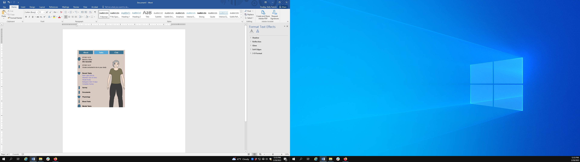Unless stated otherwise, please write your answers in **complete sentences** for this lab.

**Assignment Overview**

* Design an ***experiment*** that you could reasonably carry out in the Islands virtual world using the islanders as your participants. *For example: Examining the effects of coffee on islanders’ ability to balance on one foot.* Come up with **your own** idea of a potential cause-and-effect relationship to study.
* The purpose of this lab is to think through the choices researchers make when designing studies. Focus on making good design choices, while realizing that there are no perfect studies!

**Getting Around the Islands**

* Remember to watch the video linked in the assignment description on Canvas, but here are some reminders:
  + There are 27 villages scattered across the 3 main islands. Click on a village, and then a household, and then a name, to see a profile
  + When a villager gives you consent, a number of task options will appear.
    - Some tasks will just be an action they will complete that doesn’t produce any data/result
    - Some tasks will produce data/result—it will appear on the top of the tasks page for that person
  + All people that you obtain consent from will show up in your **Contacts** on the **top right.**
* Note that **islanders SLEEP** generally between the hours of **10pm - 6am** (their eyes will be closed), so they will not be available to complete tasks during these times or give consent!

**Question 1** (6pts): Describe in about **2-4 sentences** an experiment that you might conduct in the islands, using islanders as your unit of observation. This briefstudy description should include the following:

* Which **task** will serve as your **treatment** factor in this experiment? *This should be something you can* ***assign*** *some or all of your participants to complete.*
* What will you use as your **response variable** in this study? *Your response variable may be* ***numeric*** *or* ***categorical***.
* Your **motivation** for conducting this experiment. Why might this treatment factor cause a certain response? Why might it be interesting/fun/useful to examine this? Please don’t go overboard! A sentence or two is probably enough.

**Here are some additional constraints and tips to help you get started!**

* **Keep it simple**. Focus on just **one** response variable and **one** treatment factor. You will complete a small version of this experiment with 10 islanders as part of your submission. It should be doable in a short amount of time!
* Be careful that you are proposing an **experiment**, not an observational study. Check the notes to better understand what distinguishes an experiment from an observational study!
* Please **don’t** add details like your **sampling plan**, or ***how* you will conduct** this experiment here. That is coming up in the next few questions!

**Question 2:** (3pts) In **1 or 2 sentences**, describe the population you want to generalize to

* Geographically, your population should be representative of all 3 islands (i.e., your population cannot just be the northernmost island, or one particular village).
* That said, you may specify a sub-population. Consider if your experiment warrants some specification…
  + a specific age range (is there a minimum or maximum age you should qualify?) a specific gender
  + School children (found in each village’s school)
  + University students (there are three universities: one each in Hofn, Arcadia, and Colmar)
  + Hospitalized patients (there are three hospitals: one each in Hofn, Kiyobico, and Maeva)
  + People with a certain job or who are part of a hobby club (check out the Bureau in each village)
  + Do I also need to keep students in a specific range?

**Question 3:** (3pts) Pose a **research question** that you could answer with your experiment

* A good research question should be slightly broader than the specifics of your experiment without straying too too far away from your experimental procedures. For example:
  + *“Does drinking 250mL of coffee affect the number of seconds islanders are able to balance on one foot if we ask them 5 minutes later?”* That’s probablytoo specific to be a good research question. My question doesn’t have to fit in every detail of how we did the study.
  + *“Does coffee affect islanders’ physical abilities?”* This is a good general study aim, but it’s too broad for the simple experiment described above.
  + Try to write a question that strikes a good balance, and then acknowledge design limitations later!

**Question 4:** (8pts) Let’s *imagine* you had completed a sampling procedure and were able to find a representative sample of **40 islanders**. Once you had identified those 40 islanders, describe how you would conduct your experiment. Please answer each part below and include the letter part with your answer.

a) Identify whether you are proposing a **randomized controlled experiment** or a **pre-post design**?

* For a randomized controlled experiment, also identify if this a **repeated measures** design or **post-measures only** design.

b) Describe how you will sort people into groups OR why you chose not to include a second group.

* For a randomized controlled experiment, identify whether you plan to use **pure random assignment** or **random assignment with blocking**. If using blocking, be clear what blocking characteristic(s) you want to use and why it would be advantageous to equalize them across groups. For randomization, specify how (what tool or process) you are using to randomly assign.
* For a pre-post design, briefly address how pre-post designs might be weaker than randomized-controlled experiments and *why* you think those weaknesses will be little to no problem with your design. **Warning:** Please review the common pre-post design limitations in the notes!

c) Discuss the ordering and timing of tasks for participants.

* For a randomized controlled experiment, identify if the control group is also completing a placebo/comparative task. If the control group is completing nothing, explain why you think that’s the best (or only reasonable) choice for your design. Also be sure to identify how much time will take place between the task and the response measure.
* For a pre-post design, be sure to identify how much time will take place between each response measure and task.

**Question 5:** (8pts) Consider these 4 categories of causality threats discussed in the notes. Please review each one and identify whether that threat **applies** or **doesn’t apply** to your study. *“Drop-out differences” is left out of this list since we would have to actually complete the study to observe if it is a threat.*

* *If it does* apply…identify **how it might apply and how serious** you think this threat is to the causality argument of your study
* If it doesn’t apply…briefly **explain why not**.

A few notes:

* For setting and timing, think realistically about how you would complete this study if the islanders were real. Comment on these as they might realistically apply.
* If it’s a *potentially* *serious* and *preventable* threat, you should rethink your design from the previous question!
* A single issue *might* relate to more than one threat category! If that’s the case, you can either acknowledge it in more than one place, or just pick one category it fits best within.

a) Group Selection

b) Setting

c) Timing

d) Test Familiarity

**Question 6:** (7pts) **Try out your design** on a **small scale**. Complete a “pilot study”using at least **10** islanders (you *can* use more, but we’re just checking for a minimum of 10).

* You can find any 10 islanders you wish. No need to do any random sampling here
* Follow your described procedures as written (or as close as you can with only 10).
* Use the appropriate Excel template provided in the Lab 6 assignment page on Canvas to record your data. Choices are:
  + PrePost_Template
  + Randomized_Control_Template
  + Randomized_Control_Repeated_Template
* **Don’t change the structure**—in particular, notice that the PrePost Template uses each measurement as one observation, with one islander contributing 2 observations each.
* Make sure that your response variable column has only **numbers** if your response is numeric *(no units, words, symbols).* If your response is categorical, be consistent with CAPITAL and lowercase type, as well as with spelling/symbols.
* Be sure to fill in all additional variables listed in the template.

**Include a SCREENSHOT of your Excel sheet here in your report**

That’s it! No need to “analyze” your data for this lab.